Name: ______________________________ Company Name: ___________________________
Tel. No.: __________________ Date: ________________
DTS Gate Motor Questionnaire.
Question 1
Which dipswitch number is used for changing motor direction on the Expert 500?
______ (2)
Question 2
How many transmitter codes can be programmed on the Elite 600?
______ (1)
Question 3
On the Expert 500, where must the low voltage transformer wires be connected on the PCB?
_____AC (1)
Question 4
How many replaceable fuses does the Expert 500 PCB have:
______ (1)
Question 5
What gate weight are the following motors designed for?
- Expert ____________ Kg (1)
- Elite ______________ Kg (1)
Question 6
Complete the wiring diagram when fitting Sentry Beams on the Expert 500
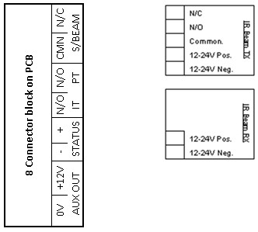
(8)
Question7
What type of relay does the Expert 500 & Elite 600 have for infra-red beams, N/O or N/C?
_________ (2)

Question 8
Explain how you erase transmitters (TX) on the Expert 500 onboard receivers?
- Individual transmitter:________________________________________________________
______________________________________________________________________________ (2)

(b) Master erase:_______________________________________________________________
_________________________________________________________________________________(2)

Question 9
Complete the wiring diagram for external receiver connections to trigger the gate for full opening function.
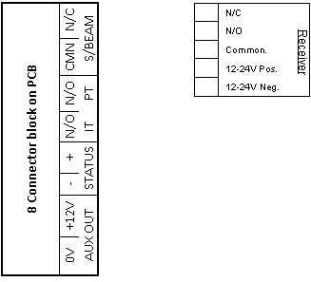 (8)
Question 10
What is the correct gate movement directions when programming (Calibrating) the Expert/Elite?
(1) ______________________ (2) _____________________ (3) _________________ (2)
Question 11
Will the gate auto close if auto close is not selected but condominium mode is selected? _______ (1)
Question 12
Which two of the six dipswitches are used on the Expert when programming the alarm/anti tamper facilities?
- Pulse alarm - ________________________________________________________
- Three minute Latch alarm - _____________________________________________ (2)
Question 13
Can the Expert/Elite be programmed to operate in holiday lockout mode?
- ______ (1)
(b) If yes, how do you activate (Not program) this mode?_______________________________
________________________________________________________________________________ (2)
(c) How would you de-activate (Not program) this mode?_______________________________
________________________________________________________________________________ (2)

Question 14
There are two reasons why the PCB will give 2 beeps but the gate will still open, what are they?
(1)_________________________________________ (2)
(2)_________________________________________ (2)
Question 15
What happens if the 25 amp Load fuse on the Expert is blown when given a trigger to open?
______________________________________________________ (2)
Question 16
What is the maximum Kg continuous pulling force on the following motors designed for?
- Expert __________ Kg (b) Elite _____________ Kg (2)
Question 17
On the Elite, where on the PCB must the High Access transformer wires be connected on pc board?
______________ (2)

Total Mark (50)

